***Problem 1:***

*JUnit pass indicator and JaCoCo statement green source line annotations:*

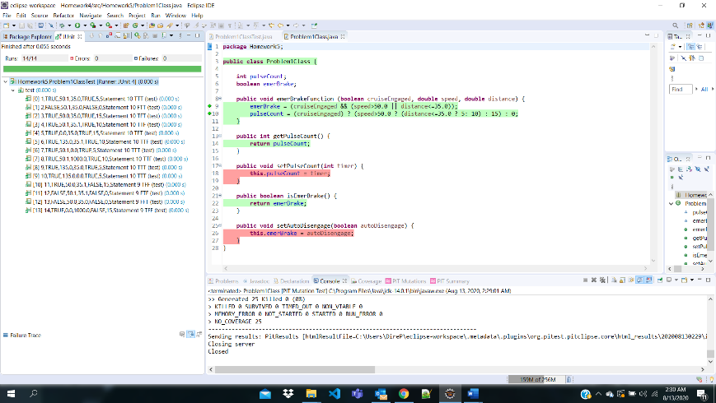

*Test Case table:*

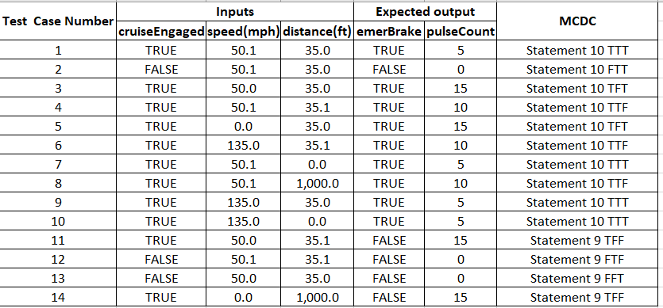

*mutators selected (PIT):*

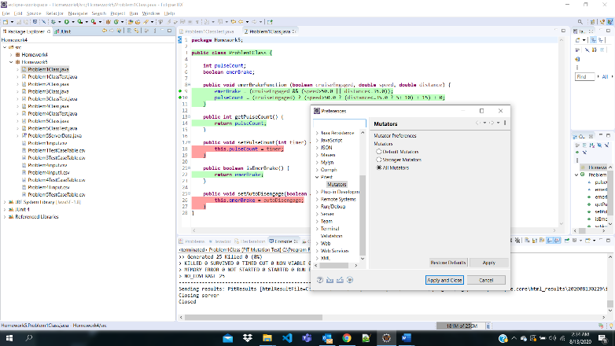

***Problem 2:***

*JUnit pass indicator and JaCoCo statement green source line annotations:*

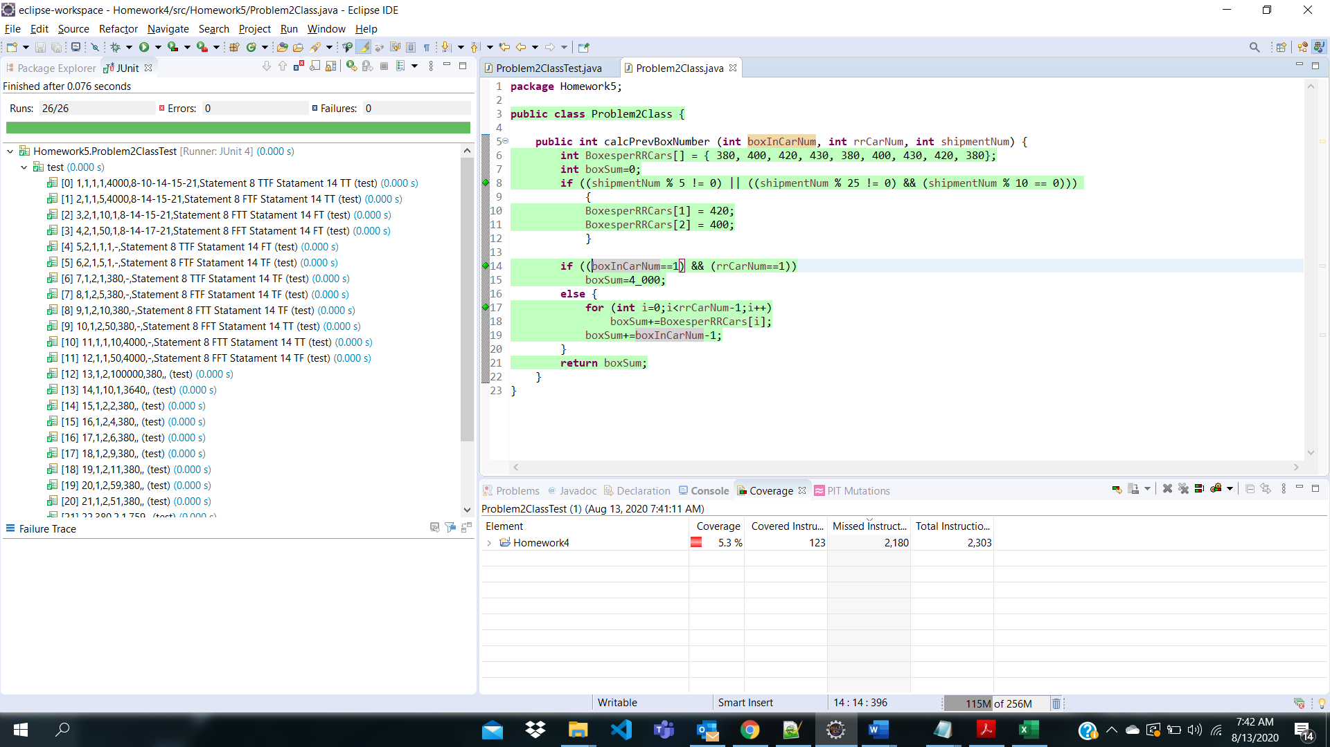

*TestCase Table:*

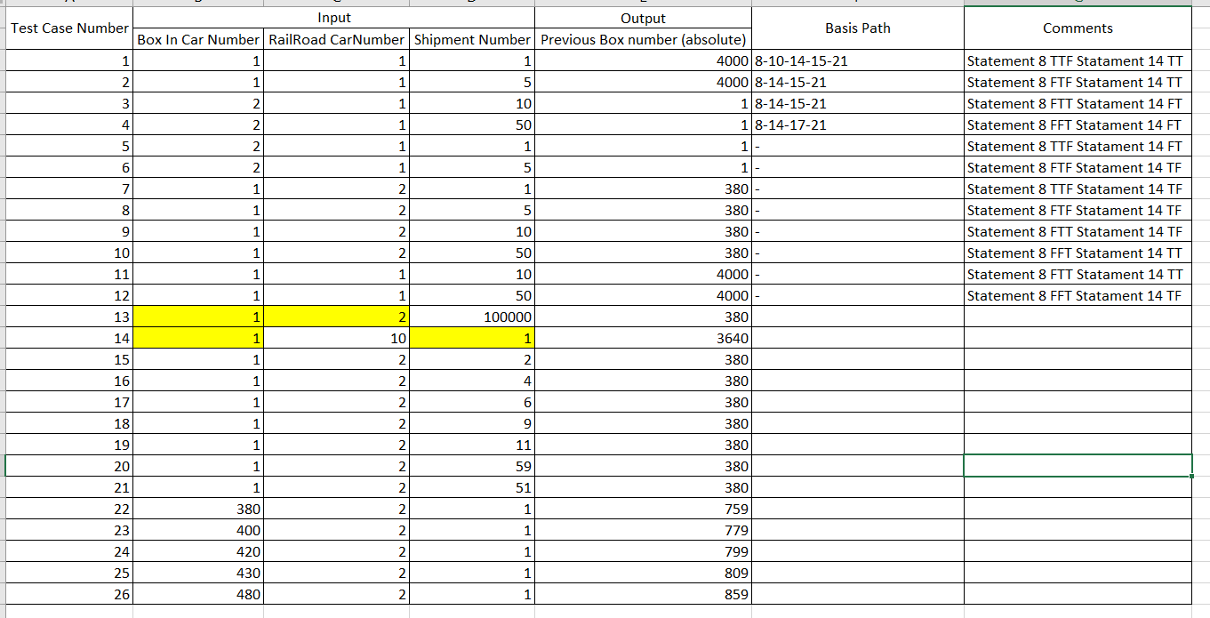

*Mutations:*

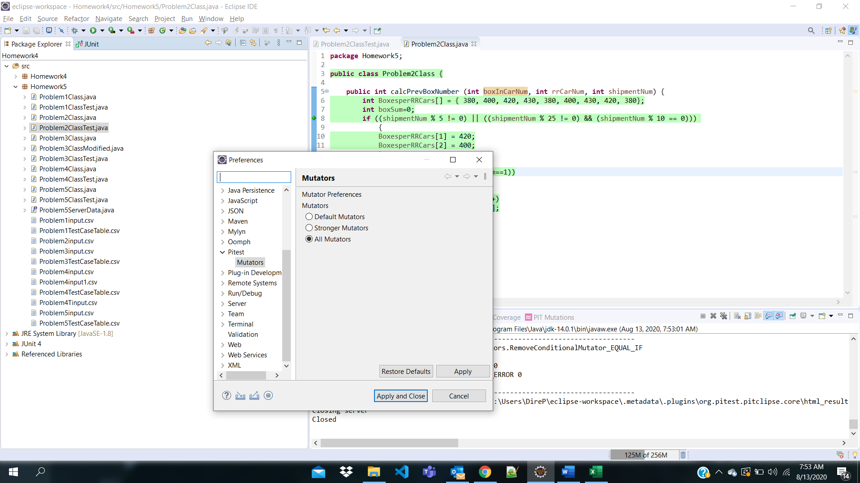

***Problem 3:***

*JUnit pass indicator and JaCoCo statement green source line annotations:*

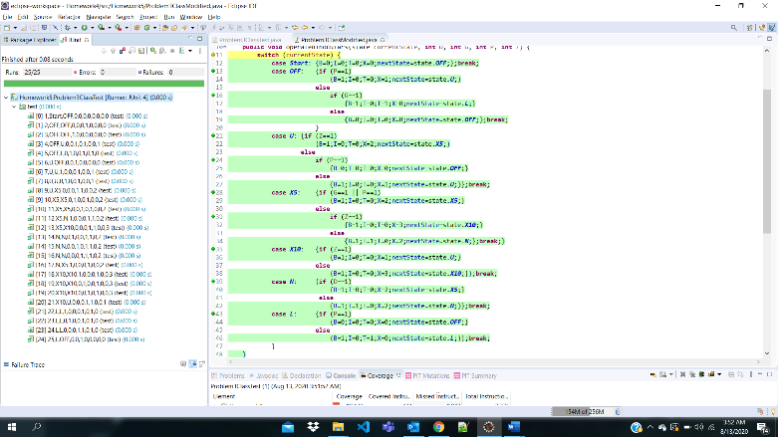

*Test Case table:*

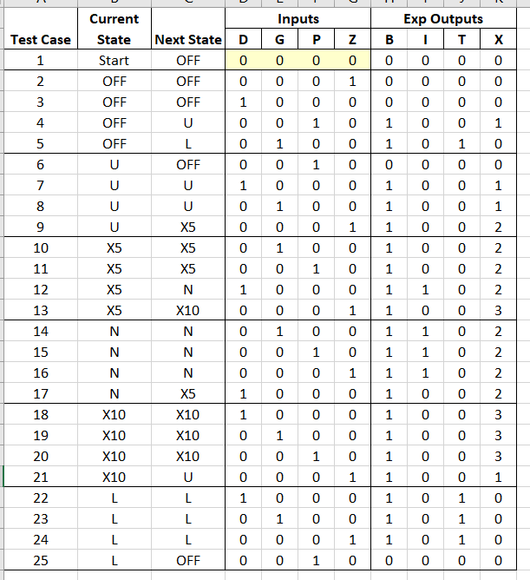

*Code changes made:*

code changes made in the Problem3ClassModified.java (line numbers referred from Eclipse) :

1. line number 12 - added **break;**
2. line number 19 - added **break;**
3. line number 22 – Modified **X=2;**
4. line number 25 – Modified **nextState=state.OFF;**
5. line number 27 – Modified **X=1;**
6. line number 28 – Modified **B==1to P==1**
7. line number 29 – Modified **nextState=state.X5;**
8. line number 34 – Modified **I=1; added break;**
9. line number 35 – Modified **P==1 to Z==1**
10. line number 36 – Modified **nextState=state.U; added I=0;**
11. line number 38 – added **break;**
12. line number 42 – added **break;**
13. line number 46 – Modified **T=1; added break;**

***Problem 4:***

*JUnit pass indicator and JaCoCo statement green source line annotations:*

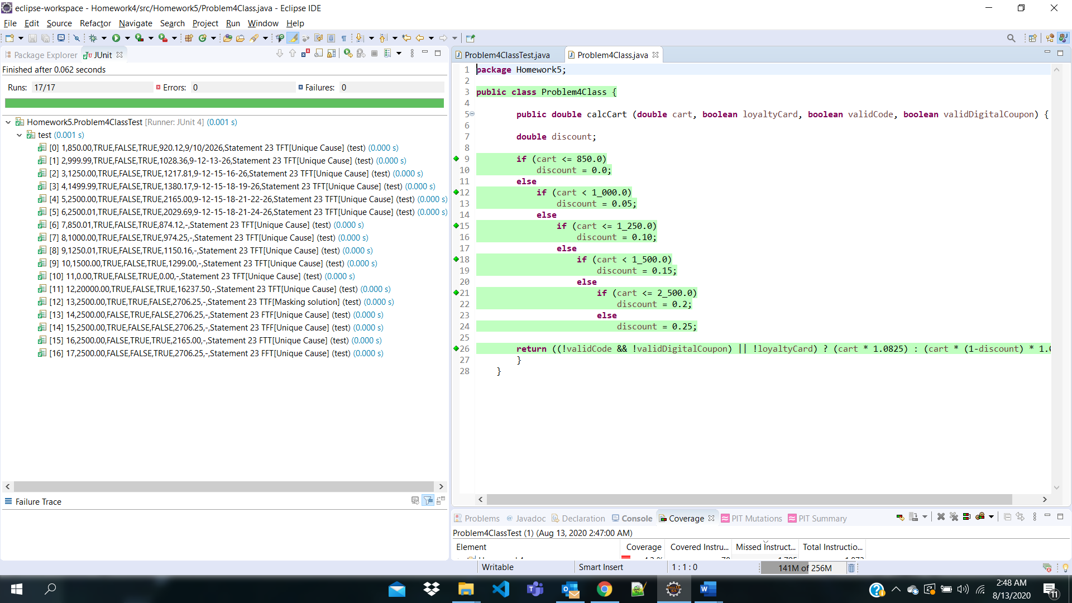

*Test Case table:*

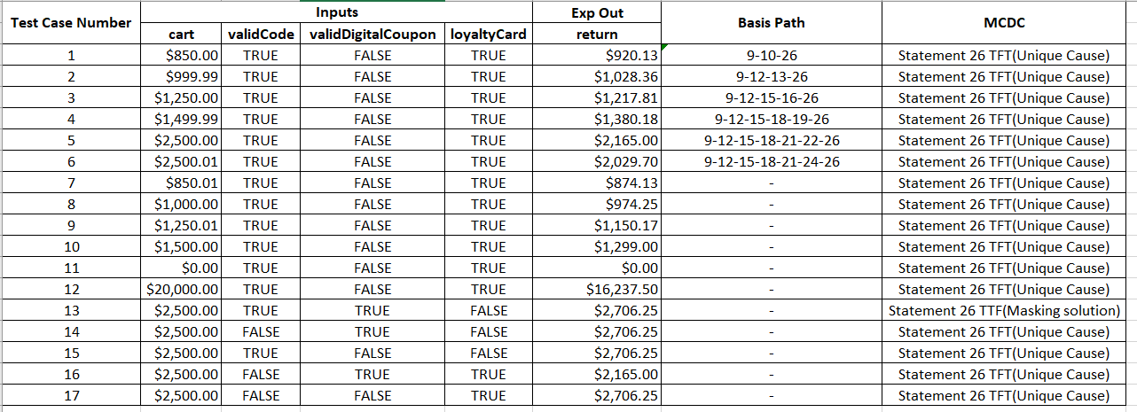

*mutators selected (PIT):*

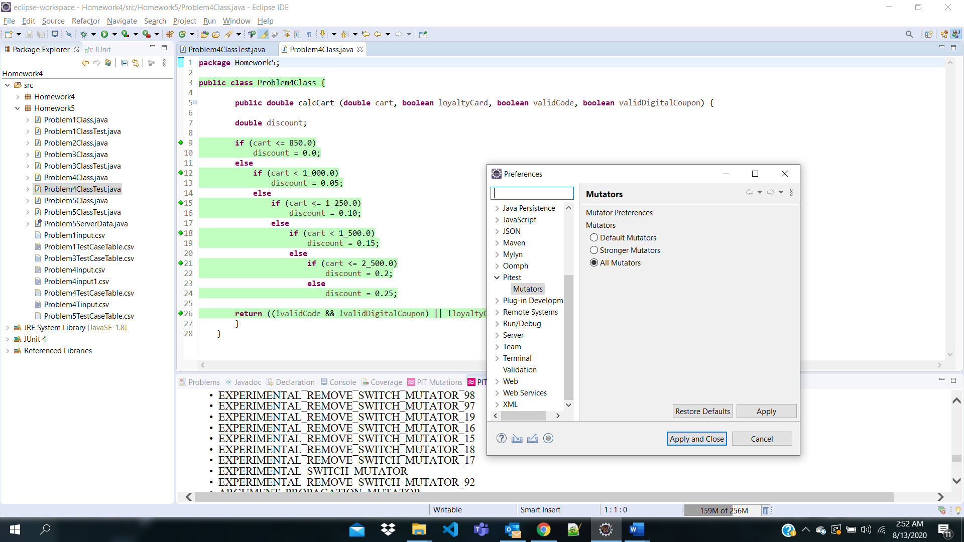

***Problem 5:***

*JUnit pass indicator and JaCoCo statement green source line annotations:*

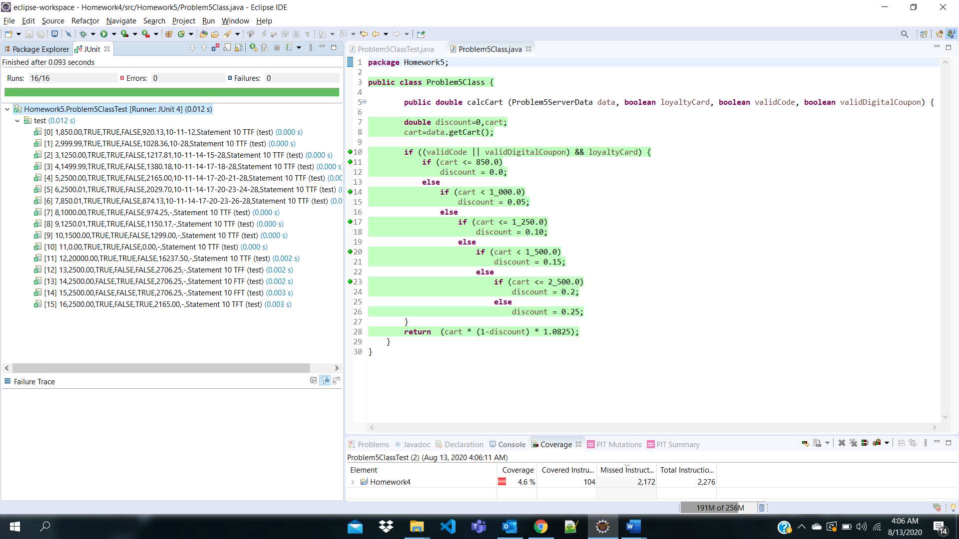

*Test Case table:*

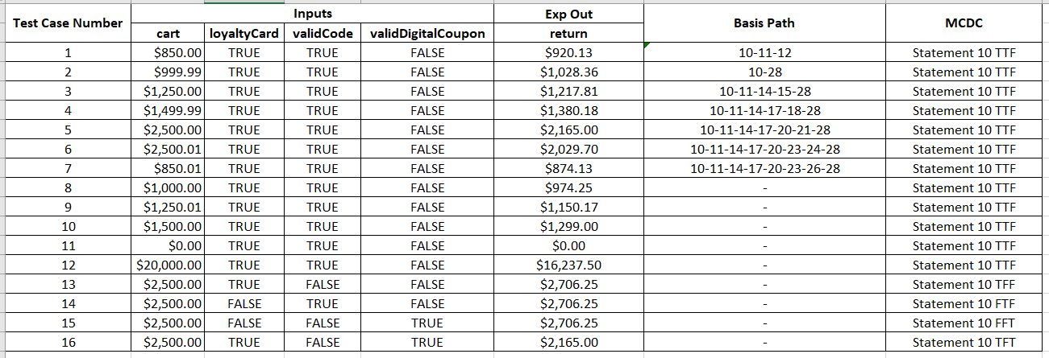

*mutators selected (PIT):*

